**SPEAKER BIOS**

**C. Wayne Honeycutt, Ph.D., President and CEO**

**Soil Health Institute**

[whoneycutt@soilhealthinstitute.org](mailto:whoneycutt@soilhealthinstitute.org)

Dr. Wayne Honeycutt is President and CEO of the Soil Health Institute, where he leads the Institute’s programs to safeguard and enhance the vitality and productivity of soils. He previously served for 5 years as Deputy Chief for Science and Technology with the USDA-Natural Resources Conservation Service (NRCS) in Washington, DC, where he led programs to ensure NRCS conservation practices reflect the latest scientific advances for conserving the nation’s soil, water, air, plant, animal, and energy resources. He served as a Research Soil Scientist for 14 years and a Research Leader for 10 years with the USDA-Agricultural Research Service in Orono, Maine, where he led and conducted interdisciplinary research on carbon, nitrogen, and phosphorus cycling and sustainable cropping systems development.

Wayne’s commitment to agriculture is rooted in his experiences with raising tobacco, corn, and other crops on his family’s 120-acre farm in Kentucky. He holds a Bachelor's degree in Forestry and Master's degree in Soil Science from the University of Kentucky, and a Ph.D. in Soil Genesis from Colorado State University. He was the 2018 recipient of the Hugh Hammond Bennett Award, the highest honor bestowed on an individual by the Soil and Water Conservation Society.

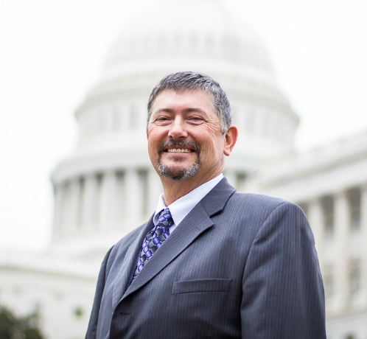**Tim Palmer, NACD** **Immediate Past President**

[redoer99@gmail.com](mailto:redoer99@gmail.com)

**Tim Palmer** operates a 1,200-acre row crop and cow/calf to finish operation near Truro, Iowa. He has served on the Madison County Soil and Water Conservation District’s board since 2003, and has held the titles of director, vice president and 2010-2011 president of the Conservation Districts of Iowa, the state’s district association.

Palmer was a governor-appointed member of the Iowa State Soil and Water Conservation Committee from 2012-2014. In 2013, he was elected to represent the NACD North Central Region, where he served for four years. Palmer and his wife Shelly, along with sons Geoff and Greg, use conservation measures extensively on their farm and are active promoters of water quality and soil health initiatives.

[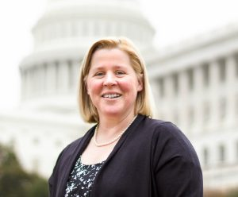](https://www.nacdnet.org/wp-content/uploads/2016/06/Kim-cropped.jpg)**Kim LaFleur, NACD First Vice President**

[kim-lafleur@nacdnet.org](mailto:kim-lafleur@nacdnet.org)

Kim LaFleur is the state advisor and program director for the Massachusetts FFA Association and an independent consultant to agricultural organizations and associations. LaFleur has served as president (2007-2010) and vice president (2010-2012) of the Massachusetts Association of Conservation Districts, an NACD board member (2007 to 2013) and an NACD executive board member (2013-2016). In 2012, she was the recipient of the NRCS/NACD Olin Sims Conservation Leadership Award.

LaFleur, along with her husband Jeff and two sons Cameron and Logan, reside in Plympton, Massachusetts, where they own and operate Mayflower Cranberries, a 112-acre cranberry farm and agri-tourism business. LaFleur also breeds and shows World Grand Champion miniature horses and serves as the chair on the Plymouth County Conservation District’s board. For five years (2009-2014), LaFleur was executive director of the Massachusetts Farm Wineries and Growers’ Association. She also holds a Bachelor of Science degree in wildlife and fisheries biology from the University of Massachusetts – Amherst.

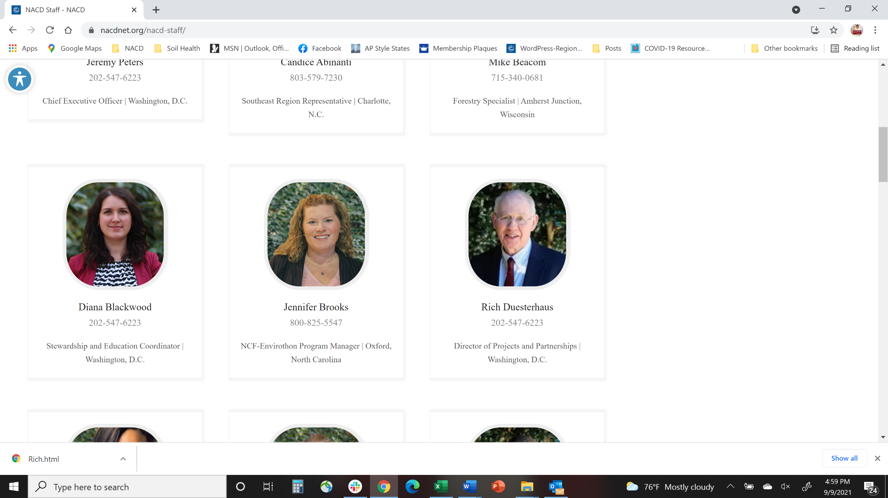**Rich Duesterhaus, NACD Director of Projects and Partnerships**

[rich-duesterhaus@nacdnet.org](mailto:rich-duesterhaus@nacdnet.org)

Rich Duesterhaus has worked in the conservation field for several decades. For the past twenty-two years he has served in several roles for NACD. For most of the last decade he has led efforts on Projects and Partnerships for NACD.

Additionally, Duesterhaus has served a career with the SCS/NRCS in the field and in Washington, D.C. as well as some assignments with USDA and OMB.

Duesterhaus has earned degrees in Agricultural Economics, Political Science, and Public Administration.